A Portable Readout System for
Micro-pattern Gas Detectors and Scintillation Detectors
Siyuan Ma^{1,2}[86-0551-63600408], Changqing Feng^{1,2}[86-0551-63600408], Laifu Luo^{1,2}[86-0551-63600408] and Shubin Liu^{1,2}[86-0551-63606782]
¹ State Key Laboratory of Particle Detection and Electronics, No.96, Jinzhai Road, Hefei, China
² University of Science and Technology of China, No.96, Jinzhai Road, Hefei, China
fengcq@ustc.edu.cn
Abstract. A system of readout electronics used in both Micro-pattern Gas detectors and Scintillation detectors is introduced in this paper. The system is intended as a general purpose multi-channel readout solution for a wide range of detector types and detector complexities. A 32-channel charge sensitive ASIC VATA160 from IDEAS company is adopted in this method. With its features of high integration, low noise and large dynamic range, this system handles up to 128 electronic channels. With integration time of 1.8 us, each channel’s dynamic range is from -3 pC to +13 pC with a noise of better than 2.5 fC and nonlinearity of better than 0.5%. As a portable system, it is able to generate trigger itself or get external trigger. This system transfers data to a PC host and gets controlled by PC via only one Universal Serial bus.
Keywords: VATA160, Readout System, MPGD, Scintillation Detector, Charge Measurement.
- Introduction

With the development of high energy physics (HEP), the Micro-pattern Gas Detector (MPGD) such as Micromegas [1] and Gas Electron Multipliers (GEMs) and scintillation detector are widely used in particle detection physics and space astrophysics [2]. In order to meet the requirement of the early stage’s test, a portable readout electronic system has been implemented and tested.
This system is based on the chip of VATA160 [3], which is a large dynamic range charge measurement readout Application-Specific Integrated Circuit (ASIC) with self-trigger function designed by IDEADS (Norway). It has 32 charge sensitive channels. The ASIC is designed for scintillation detector and MPGD. This system, which can acquire 128 channels of charge inputs, has been developed and can be used to research the performance of MPGDs as well as scintillation detectors. With integration time of 1.8 us, the dynamic range is from -3 pC to +13 pC, and the noise is better than 2.5 fC. This system is compact and portable to use. It communicates with the PC via only one USB bus. Since its total power dissipation is lower than 2.5 W, it is able to be supplied by this USB bus. This system generates trigger itself or gets external trigger.
- Implement of Readout System
Fig. 1. Block diagram of electronic board.
The block diagram of electronic board is given in Fig. 1. It mainly consists of 4 VATA160 chips, 4 Analog to Digital Converters (ADC), a Field-Programmable Gate Array (FPGA), 2 Digital to Analog Converters (DAC) and a USB interface chip. Each VATA chip has a connector of 2×32, 50 mil double row pins, which is very common in detectors, as interface to detectors. Since the MPGDs often sparks, which may damage the measurement channel of VATA160, the Electro-Static Discharge (ESD) protection is necessary to the system. The Chip NUP4114, which can bear the ESD of 16000V Human Body Model (HBM) or 400V Machine Model (MM), is adopted in every input channel. the ADC of AD7944, which converts analog output of VATA160 into digital signal, is used in this system. AD7944 is a PulSAR ADC with 14-bit resolution, and the ENOB is 13.5 bits. One DAC is used to set threshold for trigger. Since the system needs calibration before using every time, the automatic calibration function has been designed on board. It is mainly composed of a DAC, an analog switch and a capacitance. To simulate the charge from detector, a controllable step voltage is generated by DAC and analog switch. Then the capacitance turns the step voltage into current pulse, which is injected into VATA160 chip’s input channel. By controlling the shift register of VATA160, all the input channels can be tested one by one.
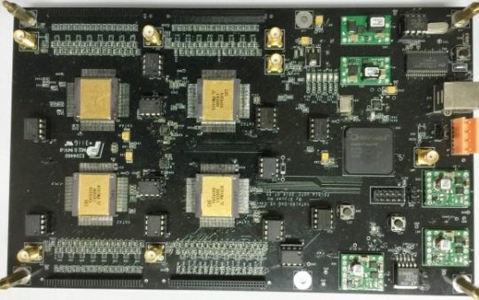
Fig. 2. Readout electronic board.
This portable readout system has been implemented as shown in Fig. 2.
- Performance of readout system.

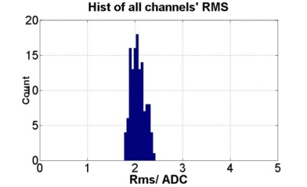
Fig. 3. RMS of all Channels.
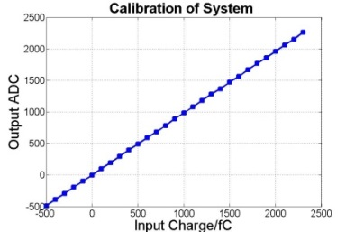
Fig. 4. Calibration of One channel.

In this section, we present the results of performance test of the readout system. The electronic noise of all 128 channels has been test and the result is shown in Fig. 3. The figure indicates that the noise of every channel is better than 2.5 Least Significant Bits (LSB), which means the equivalent input charge is 2.5 fC.
Every channel of this system has been calibrated. As is shown in Fig. 4, the typical result of integral nonlinearity (INL) between -500 fC to +2.5 pC is better than 0.5%. The range of -500 fC to +2.5 pC covers most of the application requirements.

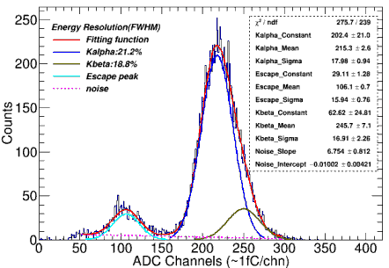
Fig. 5. The spectrum of 55Fe
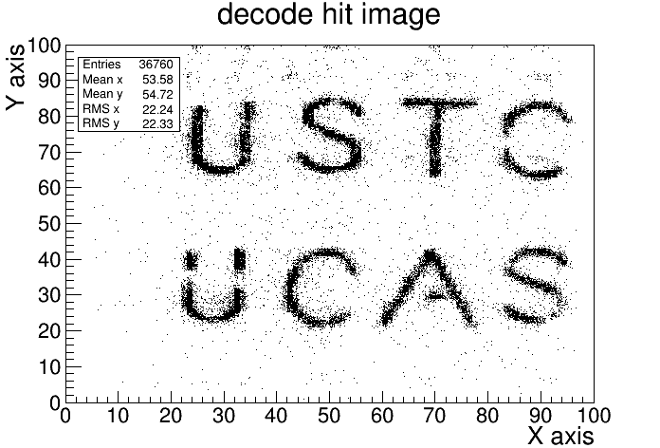
Fig. 6. The results of decoded image

This system was coupled with a Micromegas detector [4] to test the energy spectrum of ⁵⁵Fe. The result is shown in Fig. 5. The all-around peak and escape peak are clearly visible, which means the readout system is capable of performing the readout of Micromegas detector.
The encoded multiplexing readout method for Thick Gas Electron Multiplier (THGEM) is a novel method which can significantly reduce the number of readout channels. [5] In this part, the readout system is connected to a THGEM detector with the Two-Dimensional direct coding readout of 100×100 anode bars to perform imaging test. There is a copper plate with letter slits between the detector and X-ray generator. After collecting the X-ray signal which enters the detector through the slit of the copper plate, the two-dimensional imaging is obtained by decoding the hit position of the incident signal. As is shown in Fig. 6, the letter gap is clearly visible when the threshold is set to triple the noise.
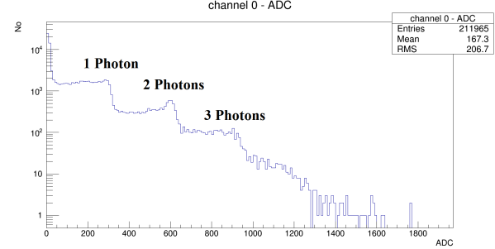
Fig. 7. Single photon peaks of SiPM
Silicon Photomultipliers (SiPM) is often used to couple with scintillation detectors to collect photons. This readout system was connected with a SiPM (S13360-1350PE of Hamamatsu) [6] to test the photoelectron peaks. This SiPM’s gain of single photon was 1.7× 10⁶. As is shown in Fig. 7, the result shows that the difference between 1 photon and 2 photons’ peak is 280 fC, which means the gain of single photon is 1.75× 10⁶. The test result is consistent with the datasheet and this means the readout system works well with SiPM.
- Conclusion.
A portable readout electronics system for MPGDs and Scintillation detectors is presented in this paper. It shows the readout systems has features of low noise (less than 2.5 fC), high dynamic range (-3 ~ +13 pC), low power dissipation (less than 2.5 W) and high integration (128 channels). This system is portable to use with only one USB bus for its supply, commands and data transmission. This system operates with different types of MPGDs and Scintillation detectors.

References
- Giomataris Y, et al.: MICROMEGAS: a high-granularity position-sensitive gaseous detector for high particle-flux environments[J]. Nuclear Instruments and Methods in Physics Research Section A: Accelerators, Spectrometers, Detectors and Associated Equipment, 376(1), 29-35 (1996).
- Jin C.: Dark Matter Particle Explorer: the first Chinese cosmic ray and hard γ-ray detector in space[J]. Chinese Journal of Space Science, 34(5), 550-557 (2014).
- IDEALS Homepage, http://ideas.no/products/ide3160-2/, last accessed 2017/6/14.
- Yunlong Z, et al.: Manufacture and performance of the thermal-bonding Micromegas prototype[J]. Journal of Instrumentation, 9(10), C10028 (2014).
- Binxiang Q, et al.: A novel method of encoded multiplexing readout for micro-pattern gas detectors[J]. Chinese physics C, 40(5), 58-62 (2016).
- HAMAMATSU Homepage, http://www.hamamatsu.com/us/en/S13360-1350PE.html, last accessed 2017/6/14.

